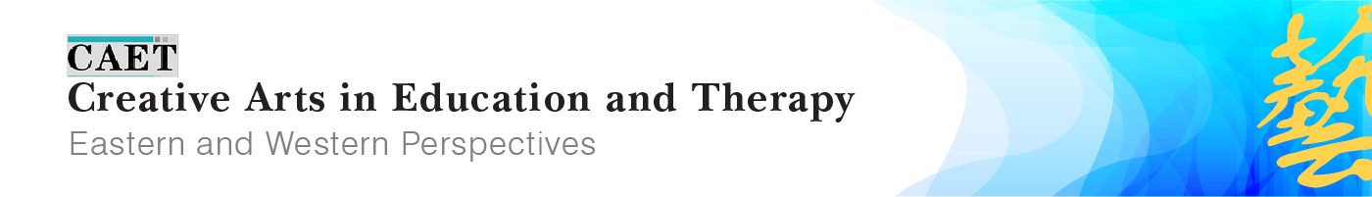
A Premier Online Open Access Journal Offering Perspectives Connecting East, West and the World
http://caet.inspirees.com

Call for Papers

Following the Covid-19 special edition and Wisdom Embedded in Nature special edition, we are calling for contributions to the special issue to be published in winter 2021: Cooperation across Artistic Disciplines and World Cultures.
Collaborations across the arts, questioning barriers between cultures, disciplines, and professions, can enhance human experience. CAET in line with IACAET’s mission and vision, is committed to cooperation, integration, real inclusion, and creation across world cultures in health, education, and therapy. This special edition will highlight the role that the arts can play in holding onto complexity and depth in the use of artistic expression to further understanding and well-being. It seeks submissions that go beyond conventional silos and engage in creative communications and relationships across professions and world communities.
The deadline of submission is September 1, 2021.

About CAET
Creative Arts in Education and Therapy (CAET): Eastern and Western Perspectives is an international open access journal published by The International Association of Creative Arts in Education and Therapy (IACAET). CAET is intended for artists, educators and therapists who use and integrate creative and expressive arts in their work. The journal’s focus is the discussion of perspectives, theory-based applications and practical results on issues concerning world cultures. The journal fosters global dialogue and supports cross-disciplinary cooperation and research between creative arts (creative writing, dance, drama, film, music, and visual arts) and education, therapy, psychology, medicine, and other related fields. CAET was founded by Dr. Tony Zhou with Shaun McNiff as the first editor in chief, now sharing the role with Debra Kalmanowitz. CAET has an editorial board consisting of 50 leading international expressive arts experts.
CAET invites research articles, case reports, program descriptions, position papers, interviews, artwork, and conference reports relevant to the field. We also welcome books for review consideration. Manuscripts are subject to a peer review process before being accepted and published. Contributions are to be in English and will be published with bilingual abstracts in English and Chinese. CAET publishes two issues per year in both print and online versions and is distributed worldwide and collected by National Library of China, Royal Dutch National Library and major art universities in China.
We cordially invite authors to contribute papers to CAET and to share perspectives among colleagues in the East, West and the world as a whole. Artistic formats are supported together with scholarly writing. Submitted manuscripts should contain no more than 4,000-6,000 words and make a direct effort to include China/Asia in their content. Full submission guidelines can be found at the CAET website http://caet.inspirees.com/for-authors/. Inquiries regarding journal policy, manuscript preparation, and other such general topics should be sent to the CAET editorial office: caet.journal@inspirees.com
We strongly recommend you to read the published CAET articles online http://caet.inspirees.com/caetojsjournals/index.php/caet/issue/archive, in order to get some idea of the styles of CAET and our requirements.
We look forward to your contribution. Many thanks in advance for your willingness to write for CAET!
Warm regards,
Executive Editorial Committee, CAET

CAET Statement
CAET was founded in 2015 to further communication and cooperation between the East and West regarding the arts in therapy, education, and human understanding. The peer review Journal, centered in Beijing, began with a commitment to bridging emerging and traditional practices in China, its neighboring countries and cultures, with arts therapy and education communities in the West where the disciplines are more established; thus the decision was made to publish in English with summaries and supporting materials in Chinese. In the Fall of 2018 CAET became an Open Access (OA) Journal, the first of its kind in the various communities that it serves. Online publication significantly expands accessibility and incorporates color, imagery, and video to more effectively present the artistic expressions which inform every aspect of the publication. The inaugural OA issue (4.1) features Outsider Art in China in dialogue with the West. CAET subscriptions are also available in hard copy.
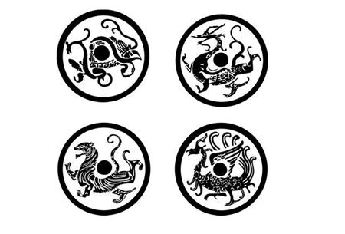
The Journal’s East-West perspective is dedicated to exploring, presenting, and understanding the necessary interdependence of all world communities — current, past, and future — as originally envisioned by the Sì Xiàng (四象), the four creatures who stand at the cardinal directions of the universe and affirm China’s historic emphasis on living in attunement with nature. Contributions regarding how artistic expressions, in their infinite uniqueness, relate to this shared humanity are welcomed from all regions of the world.
The Journal encourages scholarly, engaging, and art-based submissions in varied media (visual art, film and video, dance, drama, poetry and literature, music, integrated arts, and all possible modes of artistic expression) presented in ways that are accessible to the public. Read more.

CAET Executive Editorial Committee
Tony Zhou, Executive Editor
Shaun McNiff, Co-Editor-in-Chief
Debra Kalmanowitz, Co-Editor-in-Chief
Nuo Yang, Assistant Editor

